

User Manual

Intended for host clients

Checkpoint attendance system

2017

Table Of Contents

Table Of Contents 2

1 Introduction 2

1.1 About the User Manual 2

2 Host Operations 3

2.1 My appointments 4

2.1.1 Create Appointment 5

2.1.2 Manage appointment 5

2.1.3 Create Report 5

2.1.4 Add selected appointment to course 5

2.2 Manage Attendance 5

2.3 My Courses 6

2.3.1 Create Course 6

2.3.2 Manage Course 6

2.3.3 Create Report 8

2.4 Alter profile 8

2.5 Log out 8

3 Troubleshooting 9

4 Contact Us 10

# Introduction

Congratulation on your first CheckPoint host account! As a host in the CheckPoint attendance system you will be able to easily create and maintain appointments and courses as well as having complete control over who is allowed and who has attended your appointments and courses.

## About the User Manual

This user manual covers all features a host account entails in the CheckPoint attendance system.

# Host Operations

Once you have logged in as a host through the CheckPoint main web page, you will be met by the *My appointments* page which is illustrated in *Figure 2‑1*.

On the left side of the web page you will find the navigation bar, from here you can access all the main host features which are explained in the following sub chapters.

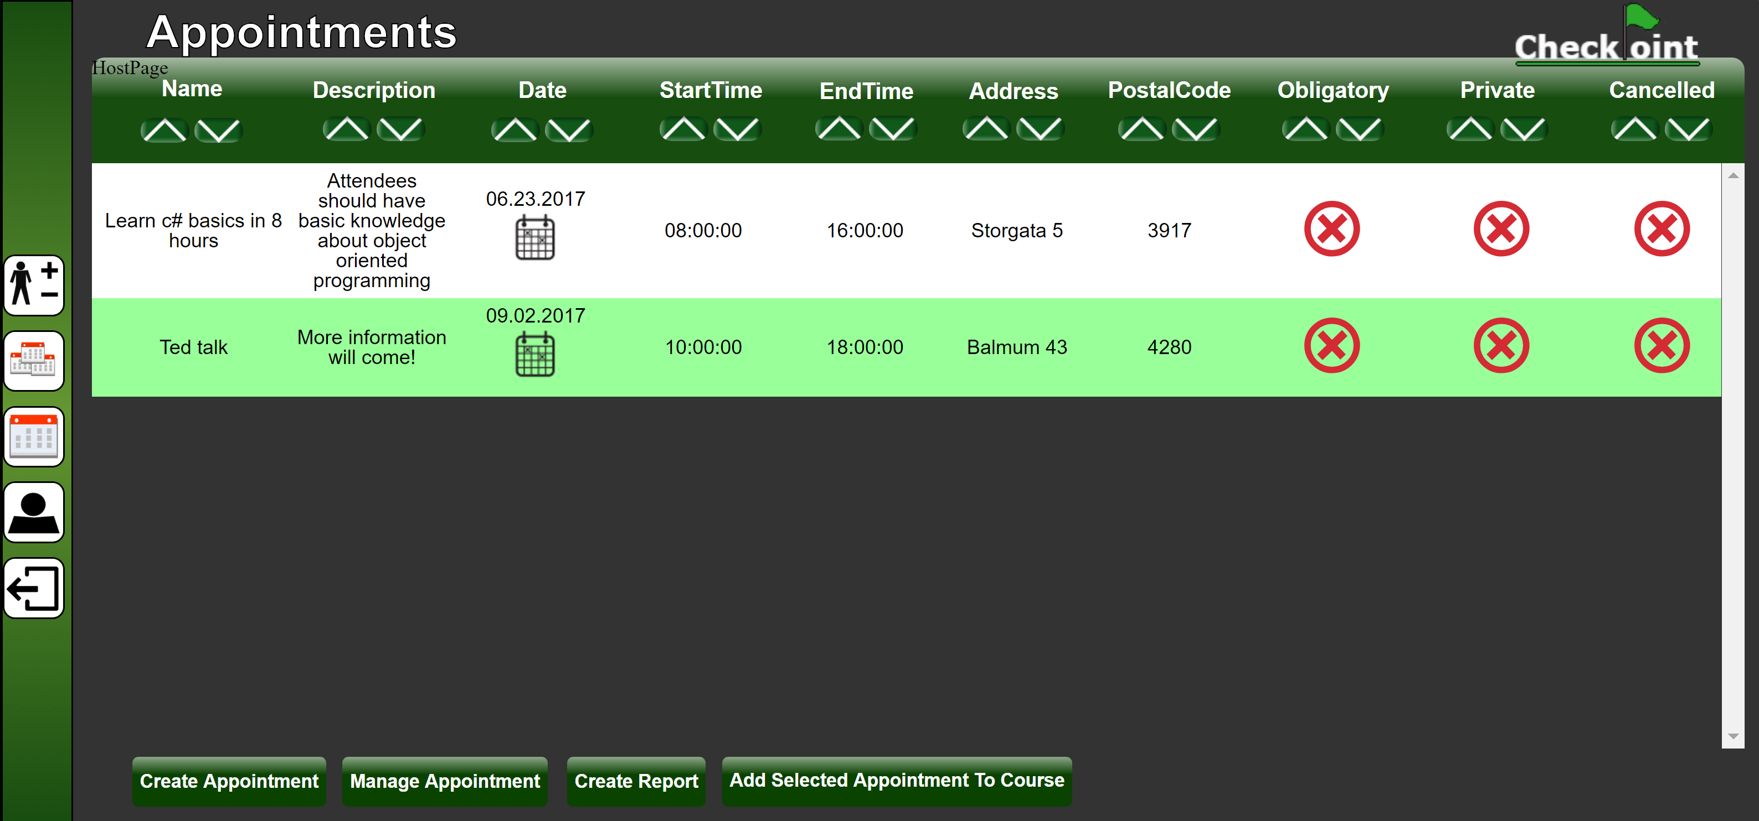

Figure 2‑1: My appointments web page with the navigation bar on the left side

## My appointments

By clicking the calendar icon on the navigation bar as illustrated in Figure 2‑2, you will access the “My appointments” web page.

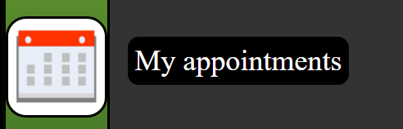

Figure 2‑2: Calendar icon on the navigation bar.

On this web page, which is illustrated in Figure 2‑3, you will get a detailed table view of all your appointments. The appointments can be sorted by each column in the table, either by clicking the sort ascending button or sort descending button in the column shown in Figure 2‑4.

You will also have the following options on the bottom of the web page illustrated in Figure 2‑3:

*2.1.1 Create Appointment*

*2.1.2 Manage appointment*

*2.1.3* Create Report

*2.1.4 Add selected appointment to course*



Figure 2‑3: My appointments web page

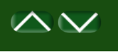

Figure 2‑4: Sorting buttons, ascending and descending.

### Create Appointment

Create a new appointment by clicking the “Create Appointment” button.  
This will redirect you to a web page where you can fill in the details of the new appointment.

### Manage appointment

Manage an appointment by selecting an existing appointment from the list and clicking the “Manage appointment” button. This will redirect you to a web page where you can edit the details of the selected appointment.

### Create Report

Coming soon!

### Add selected appointment to course

Add an appointment to a course by selecting an existing appointment from the list and pressing the “Add Selected Appointment to Course” button.

This will redirect you to a new web page with a list of all your current courses, here you can choose which course the appointment will be added to.

After you have added the appointment to the course of your choosing, you will be redirected to the course management web page. This web page is explained in chapter *2.3.2 Manage Course .*

## Manage Attendance

To access the “Manage Attendance” web page, click the Manage Attendance icon on the navigation bar as illustrated in Figure 2‑6.

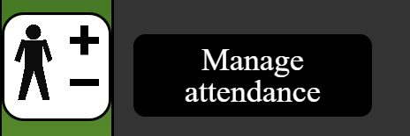

Figure 2‑5: Manage attendance icon on the navigation bar

Coming soon!

## My Courses

To access the “My Courses” web page, click the My courses icon on the navigation bar as illustrated in Figure 2‑6.

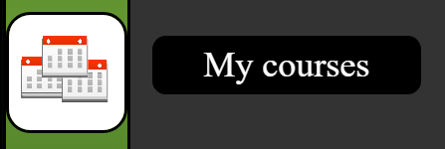

Figure 2‑6: My courses icon on the navigation bar

On this web page, which is illustrated in *Figure 2‑7*, you will get a detailed list view of all your courses. The courses can be sorted by each column in the table, either by clicking the sort ascending button or sort descending button in the column shown in Figure 2‑4.

You will also have the following options on the bottom of the web page illustrated in Figure 2‑7:  
  
*2.3.1 Create Course*

*2.3.2 Manage Course*

*2.3.3 Create Report*

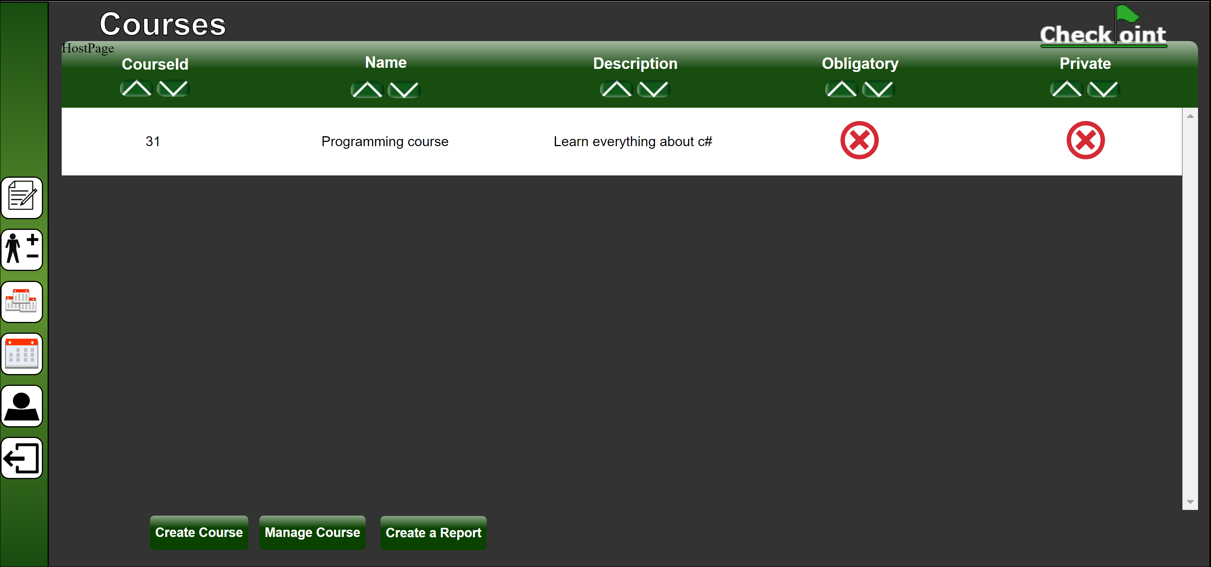

Figure 2‑7: My Courses web page

### Create Course

Create a new course by clicking the “Create Course” button.  
This will redirect you to a web page where you can fill in the details of the new course.

### Manage Course

Manage a course by selecting an existing course from the list and clicking the “Manage Course” button. This will redirect you to the manage course web page as illustrated in  
*Figure 2‑8.*

The top table (marked as 1) in *Figure 2‑8* shows the course you are currently managing, while the table below (marked as 2) shows all the current appointments in the course.

You will have the following options at the bottom of the web page shown in *Figure 2‑8*:

*2.3.2.1 Update Course*

*2.3.2.2 Delete Course*

*2.3.2.3 Remove the selected appointment*

*2.3.2.4 Move the selected appointment to another course*

*2.3.2.5 Add another appointment to this course*

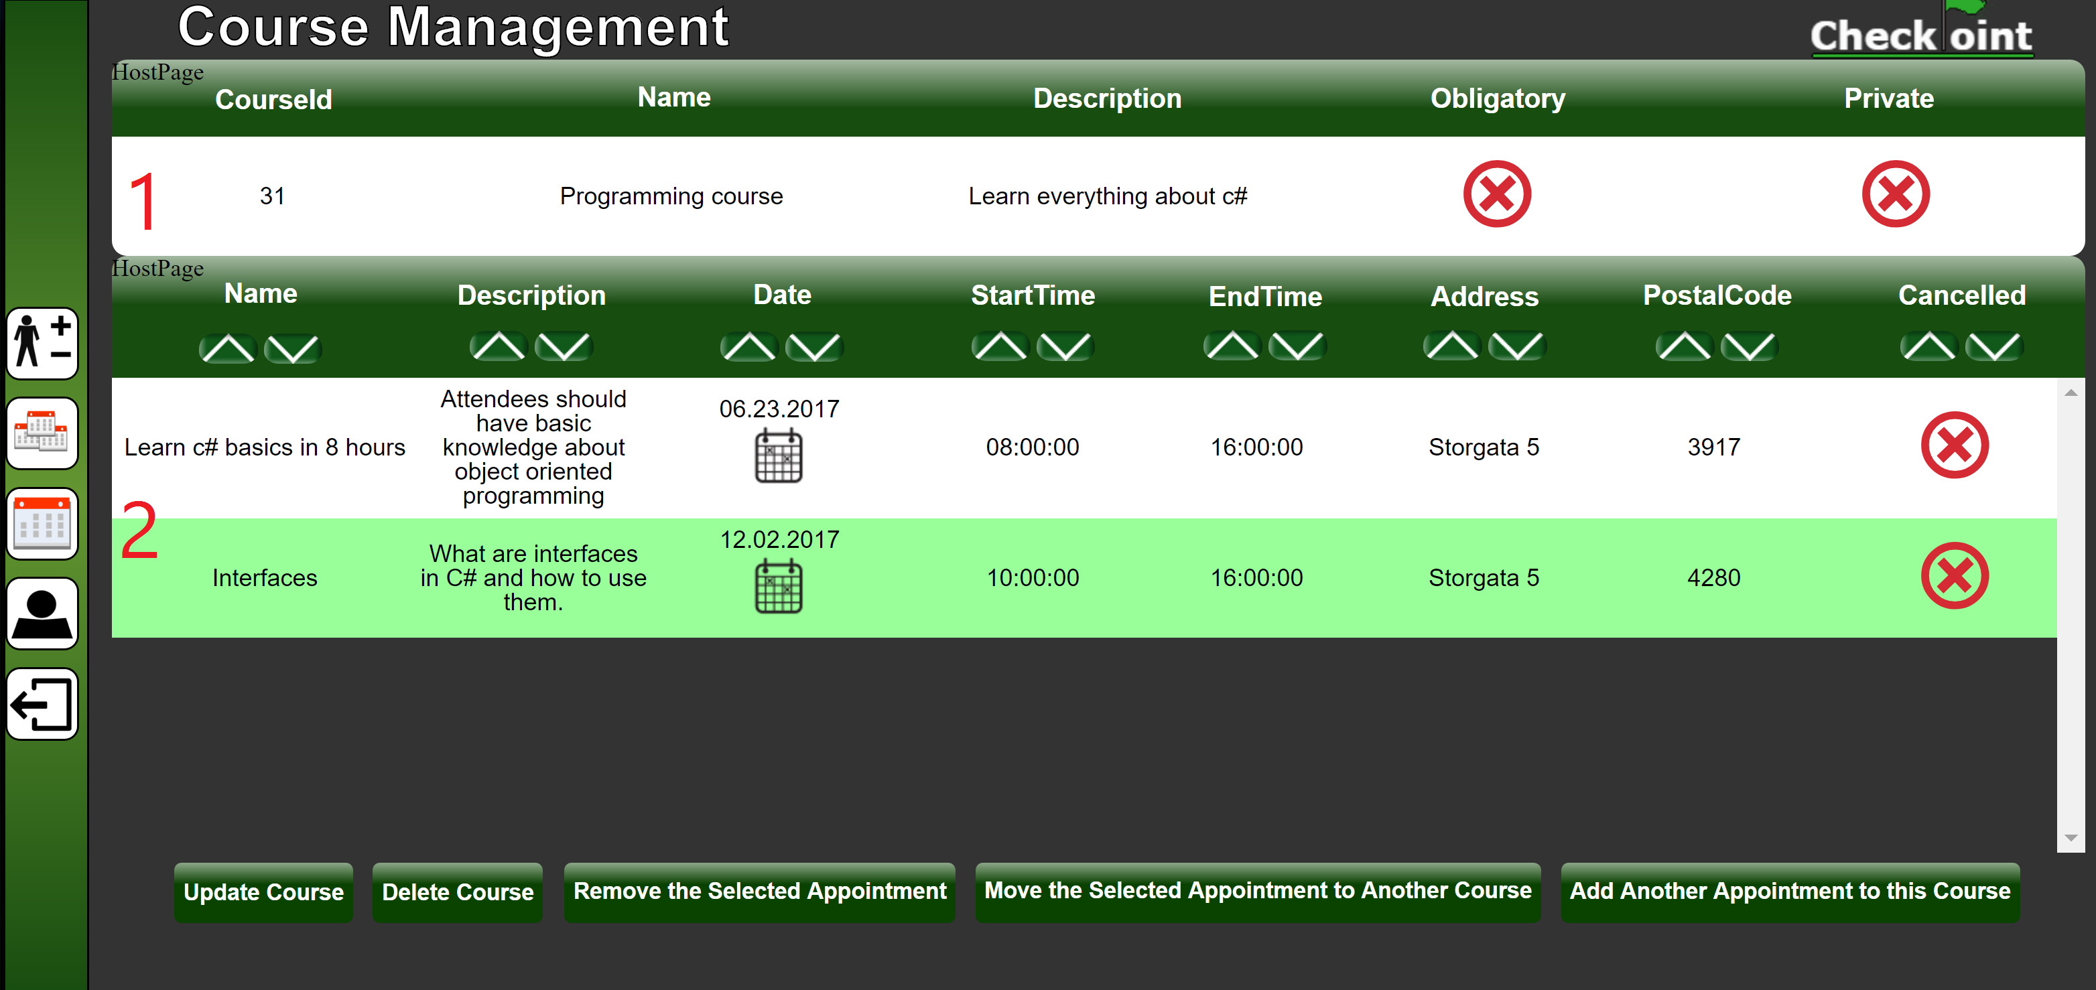

Figure 2‑8: Manage Course page

#### Update Course

This will redirect you to a web page where you can update the details of the course.

#### Delete Course

This will redirect you to a delete course web page, where you can confirm the deletion of the course. Deleting the course will also delete the appointments in the course.

#### Remove the selected appointment

Select an appointment in the list and click “Remove the selected appointment” button to remove it from the course.

#### Move the selected appointment to another course

Select an appointment in the list and click “Move the selected appointment to another course” button. You will then get redirected to a new web page where you can select which of your courses the appointment will be moved to.

#### Add another appointment to this course

By clicking “Add another appointment to this course” button, you will be redirected to a web page where you can select an appointment from a list of all your appointments and add it to the course.

### Create Report

Coming soon!

## Alter profile

By clicking the alter profile icon on the navigation bar as illustrated in *Figure 2‑9* you will get redirected to a web page where you can edit your own profile details.

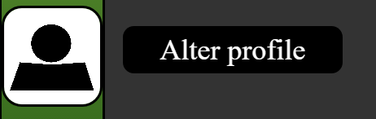

Figure 2‑9: Alter profile icon

## Log out

By clicking the Log out icon on the navigation bar as illustrated in *Figure 2‑10* you will be logged out of the CheckPoint system and redirected to the CheckPoint homepage.

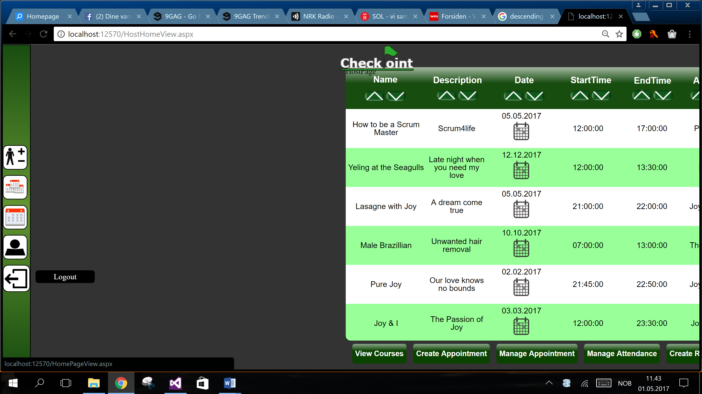

Figure 2‑10: Logout icon

# Troubleshooting

This chapter will address the most common problems you might experience when using the CheckPoint system. It will be presented in a Q&A style.

*Add this if needed*

# Contact Us

Feel free to contact us should you need any information or if you are experiencing any problems with our product.

* *Support & General:*

+004746837573 (24/7)

* *Email:*

Support@CheckPoint.com